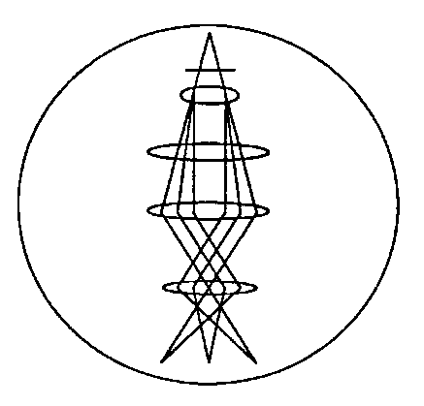

Microscopy Society of
Northeastern Ohio, Inc.
An affiliate society of the
Microscopy Society of America
and the Microbeam Analysis Society

Visit us on the web at www.msneo.org

MEMBERSHIP APPLICATION AND RENEWAL FORM

Date: ______________________________

Name: _______________________________________________________________________

Position (Title): _______________________________________________________________

Institution: ____________________________________________________________________

Address: _____________________________________________________________________
(Mailing)
______________________________________________________________________

______________________________________________________________________

City: __________________________ State: __________ Zip Code: _______________

Telephone (Business): ______________________ FAX: ________________________

Telephone (Home): ________________________ E-Mail:_______________________
(If retired, unemployed or prefer contact at this number.)

Principal EM Interest: Membership in Affiliated Societies:
Biological Sciences: ____ MSA: _____
Physical Sciences: ____ MAS: _____

Membership Type (Annual Dues)
Professional ($20): _____ Student ($5): _____
Corporate ($50): _____ Retired: ($5): _____
Lifetime Membership ($200): _____
Unemployed (Waived): _____

Make your check payable to: MSNO
Please mail this form with your dues payment to: Richard Kus
311 Cedarbrook Dr.
Painesville, OH 44077
E-mail : kusricka@yahoo.com
E-mail: microsocietyneo@gmail.com

